Prof. Srinivasan, COMSC-076
Evergreen Valley College
Spring 2026

LIBRARY MANAGEMENT SYSTEM
PROJECT REPORT — GROUP 5

Purpose and Functionality Requirements
The purpose of this project is to build a library management system that maintains an inventory of available books. Users are able to interact with the system with the following functionality.
- Add books (including attributes for title, author, ISBN, publication year, and the availability status for the book)
- Search for books by title, author, or ISBN
- Borrow and return books
- View a list of available books
- Save and load book data to and from a file

Problem
The problem was to identify a suitable data structure for efficiently keeping track of books within the library management system. Multiple factors had to be considered in the context of time complexity to meet the requirements.
- Searching for a book
- Adding a book or loading the full list of books from a saved file
- Updating the availability of books as they are borrowed and returned

How often each operation is used was also considered, assuming that the management system is deployed at a local in-person library.
- It is likely that users are not frequently searching for a specific book at a library. Instead, users are often exploring books categorized by labeled sections or asking the librarian where the shelf is for a specific genre.
- Users are often checking out or returning multiple books upon entry or departure.
- Loading the full list of books from a saved file needs to happen only once in the event of a power outage or system restart.

With this criteria noted, the decision was made to move forward with the HashMap data structure, with the ISBN of the book being the key and the book object being the value. The HashMap data structure has O(1) time complexity when searching as the key is a reference to the object. This is critical for reducing the number of operations from high-traffic scenarios, such as long lines of people checking out and returning books. When checking out and returning a book, the bar code sticker on the book is scanned for each book. The bar code contains the book’s unique ISBN making it easy for the management system to locate the book object and internally update the number of copies for the book.

However, using ISBN as the key is not ideal for when users are searching for a specific book in the library’s catalog. The user is usually searching by title or author, which are not indexed by the library management system. This means that when searching by those attributes, the time complexity becomes O(n) as the full list of books must be traversed. The management system uses HashMap which is an unordered list, making Liniar Search the only option.

It was deemed unnecessary to create and maintain multiple hash maps to have direct references for the title and author attributes as users are not searching for specific books as often as checking out and returning books. Therefore, for a local library, there is not as much of a difference efficiency-wise for having O(1) time complexity for searching.

Team Roles

Eric Chevrie | Maintainer for the Github repository, organized and added all issues, wrote JUnit tests, added edge case guards and code fixes.
Evan Ha | Implemented parsing, serializing, available copies, check in/out, wrote main shell commands
Jesse Hawkes | JavaDoc documentation, and implemented the equals and hashCode methods
Marlon Lopez Rivera | Implemented search and modified Save/Load for json format
Joseph Monteon | Implemented add/remove command handling and error handling
Aksham Tuteja | Implemented the data structure and created the Project Report

The team effectively communicated through Discord. Teammates took initiative in delegating and completing tasks as well as assisting others with their tasks and navigating GitHub.

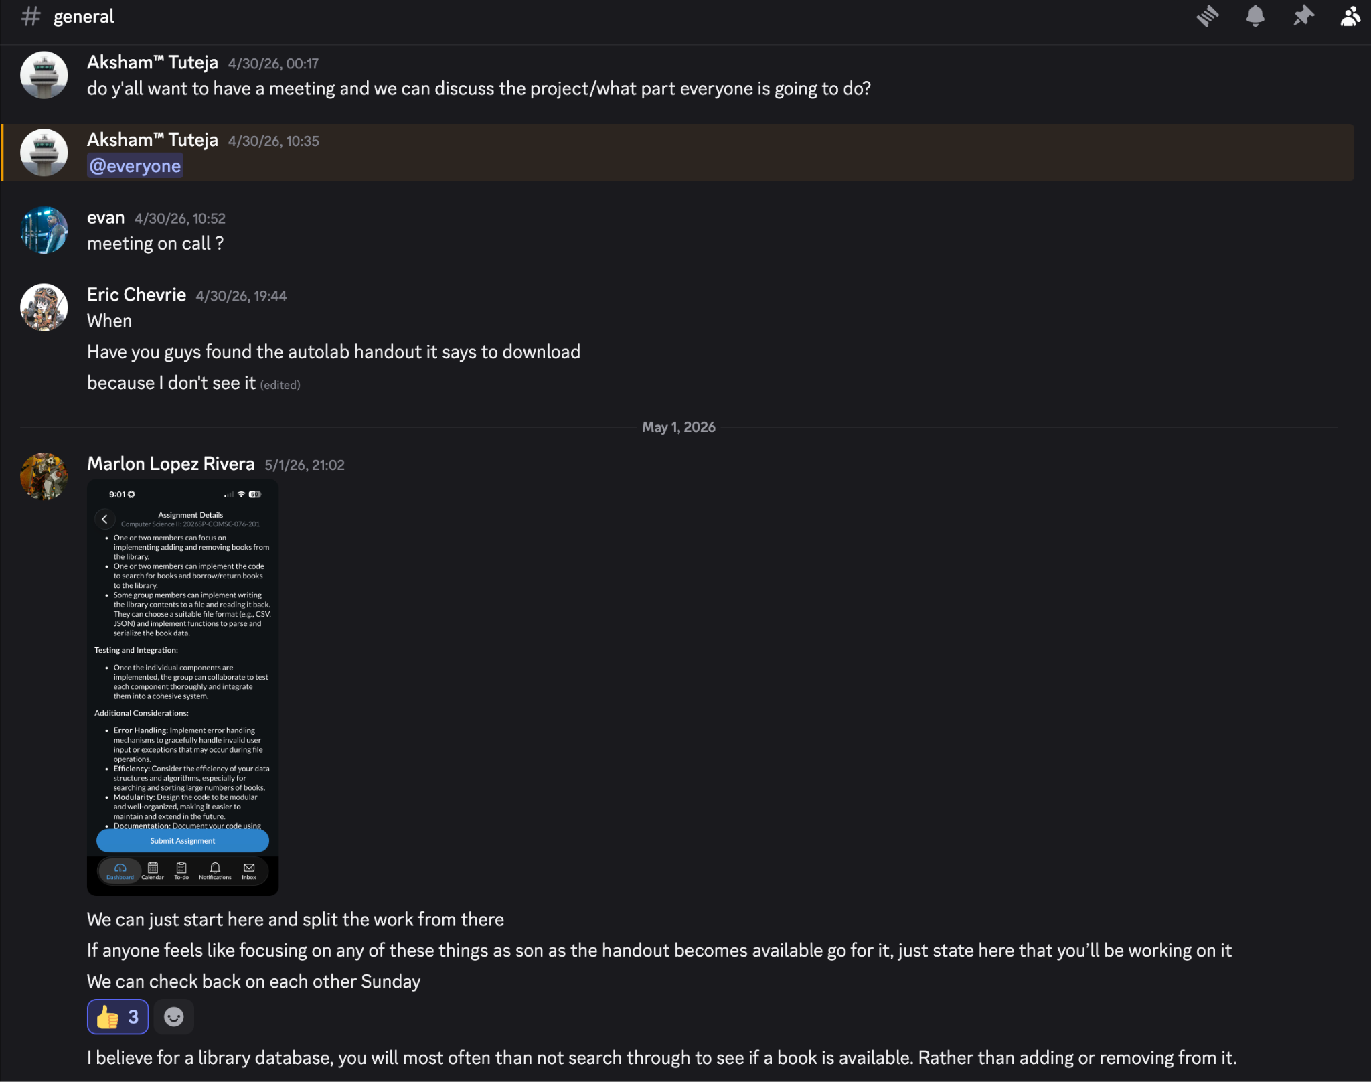
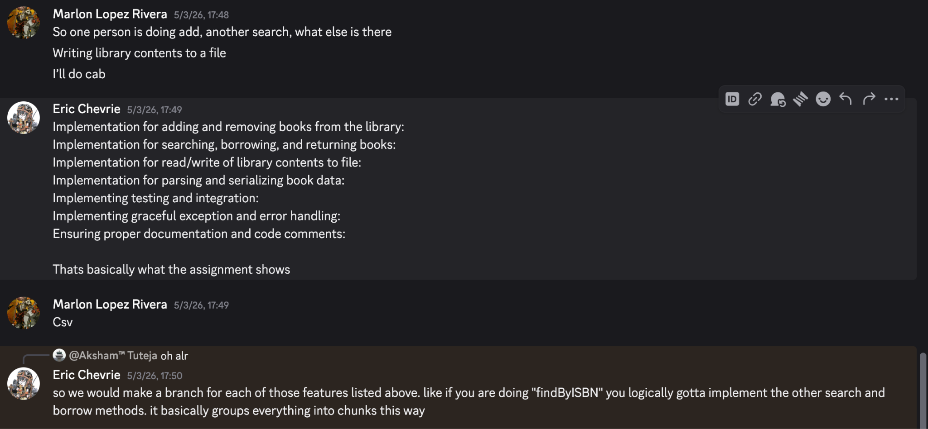
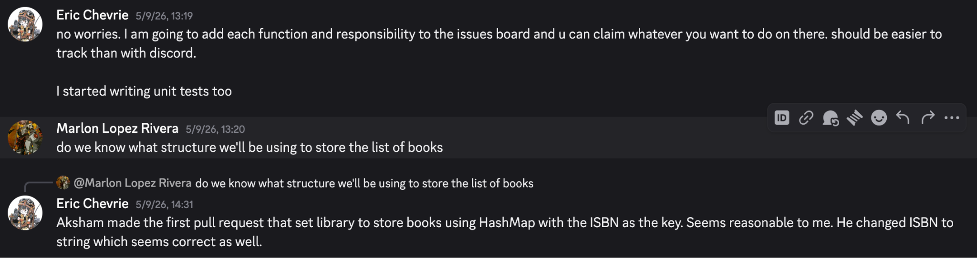

The project was organized by issue on github and each member was able to assign themselves to each task for better organization. All features were implemented on branches and reviewed before being merged, and tested against written unit tests.

